Algorithm for file updates in Python

Project description
I am part of a cybersecurity team at a healthcare facility. My main task is to ensure that only authorised employees have access to SPII, based on their IP addresses. I achieve it through a designated list of IP addresses, "allow_list.txt", and an algorithm that removes IP addresses of machines of employees who have authorisation no more.

Open the file that contains the allow list
The initial step of the algorithm is to open "allow_list.txt". Hence, I assign the file name to the import_file variable:

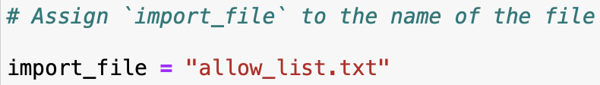

After that, I utilize a with statement to open the file:
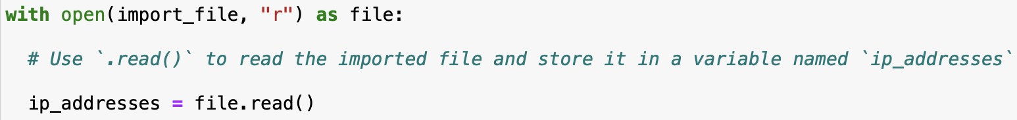

I use with to avoid errors and manage external resources when opening and closing a file; as is necessary to assign a variable file which stores the data inside the with statement. I need to utilize the open() function with the "r" parameter that grants me reading privileges to import_file.

Read the file contents
To parse the content of import_file, I employ the .read() method to make it more human-readable.
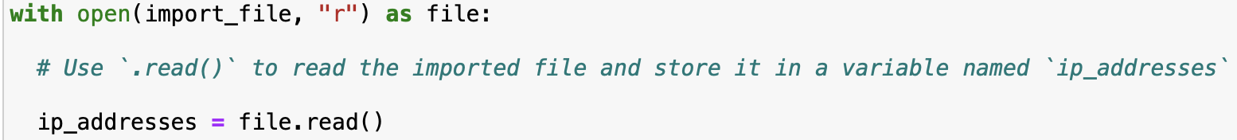

Since I open the file with reading privileges with the .open() function, I can execute the .read() function inside the with statement. As all the data is stored in a temporary container file, I attach the function to it.

Convert the string into a list
After reading the file, I need to convert the string ip_addresses into a list. In order to achieve this, I decide to use the .split() function.

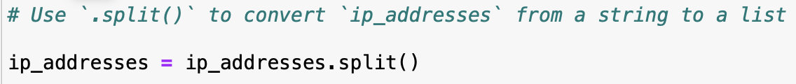
The .split() function is normally added at the end of a variable. It would separate the contents of a variable based on the character that is specified as an argument. Without an argument, it can separate based on a space character and/or return. The main purpose of this function in my code is to simplify the removal of IP addresses from the relevant list. I can store the list by reassigning it back to ip_addresses.

Iterate through the remove list
Iteration through the ip_addresses is a cornerstone of my algorithm. It is achieved through the means of a for loop:
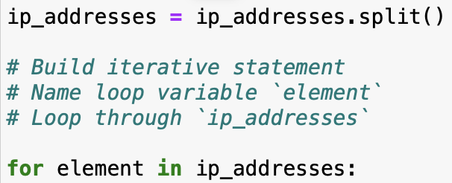

The for loop runs the code using each element of a list as a variable. The loop begins with for followed by the loop variable element and the keyword in. The keyword identifies a list of variables that should be run through the loop.

Remove IP addresses that are on the remove list
The goal of the algorithm is to remove all of the IP addresses specified in the remove list from the allow list. To achieve this I write a conditional that assess whether an element variable is part of ip_addresses.
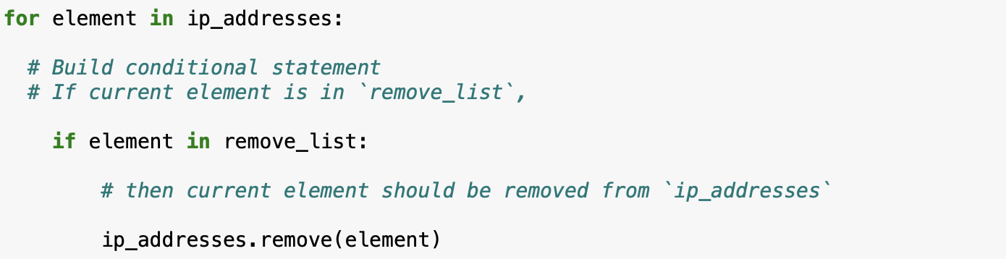

Within the conditional I include the .remove() function with element as an argument. The function removes the first occurrence of a specific element inside the list.

Update the file with the revised list of IP addresses
Ultimately, I need to update the algorithm with the modified list. To achieve this, I convert the ip_addresses into a string by means of the .join() method so as to be able to pass ip_addresses as an argument.

In general, the .join() method is used to concatenate the elements of an iterable into a string. Normally, the iterable gets included as an argument (in my case it is ip_addresses ) that is appended to a separation character "\n" (which instructs Python to insert each element on a new line)
Having done that, I employ the with statement with the .write() method:
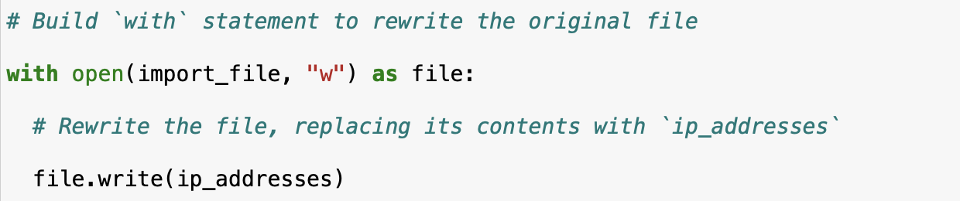

Contrary to the previous usage of the with statement, I use a "w" argument because I need permission to write to the file. With this permission I can finally call the .write() command to write a string data into the file "allow_list.txt". It fulfills the sole purpose of my algorithm which is to ensure that the IP addresses of employees that have their access terminated are not able to access company’s internal data per se.

Summary

In this overview, I develop an algorithm to keep the list of authorised IP addresses to access SPII at the healthcare facility current. First, I import a designated list of IP addresses, "allow_list.txt" and make necessary modifications to prepare it for automation such as parsing and conversion into a list and a string through the .read() and the .open() commands. Next, I iterate through the ip_addresses with a for loop to designate IP addresses for deletion. After that, I remove all of the IP addresses from the allow list by means of the .remove() function. In the end, I record the changes made by the .remove() function with the .write() method.

